Acropolis Institute of Technology and Research

**Project Title :-**

AI-generated reports on sustainable fishing practices

Training Program on Generative AI

Name: Khushi Agrawal Submitted To:

Enrollment No. : 0827IT221076 Department : Information Technology Date of Submission : 01/09/2025

# Abstract :-

# The *GenAI Project – AI-Powered Report Generator on Sustainable Practices* demonstrates how Generative Artificial Intelligence (GenAI) can transform one of the most repetitive academic and professional tasks: report writing. In academic contexts, writing detailed reports consumes a large amount of time and energy. Students spend hours on drafting, structuring, and formatting content. Similarly, professionals dedicate significant resources to documentation. This project addresses these challenges by designing a **system that automates report generation using AI models integrated into a web application.**

# The system works by combining a **frontend interface** with a **Flask backend** and a **Perplexity Sonar Pro AI model.** The frontend, created with HTML and CSS, provides fields for the user to enter details such as the report title, audience, scope, and focus areas. Once submitted, the data is passed to Flask, which communicates with the AI model. Through carefully crafted prompts, the AI generates clean HTML content with headings, paragraphs, and bullet points — ensuring outputs are free from Markdown symbols like #, *, or -.

# The **purpose** of the project is twofold. First, it seeks to reduce the manual workload of report writing by automating the process. Second, it ensures that the outputs are **submission-ready**, requiring minimal human editing. This makes the project relevant not just for students preparing academic reports but also for professionals drafting project documentation.

# A demonstration was carried out with the topic *“Sustainable Fishing Practices in the Bay of Bengal.”* The system produced a report structured into sections such as Summary, Key Challenges, Best Practices, Community Monitoring, and Action Checklist. Each section was logically ordered, making the document not only informative but also visually clean.

# The abstract underscores the significance of combining AI technology with sustainability themes. While the system is general-purpose and can be used for any topic, testing it on sustainability ensured that it aligned with pressing global issues. This highlights the role of AI not only in technical innovation but also in creating awareness.

# In conclusion, the project proves that **GenAI can act as an academic assistant**. It can save time, maintain formatting standards, and enhance productivity. The abstract encapsulates the project’s scope: building a tool that makes report writing faster, cleaner, and more efficient.

# Objective :-

The primary objective of the project *GenAI – AI-Powered Report Generator on Sustainable Fishing Practices* is to design and implement a system that automates the process of generating structured academic reports using **Generative Artificial Intelligence (GenAI)**. While report writing is one of the most common academic and professional tasks, it is also one of the most time-consuming. Students often spend long hours drafting, formatting, and organizing their projects, while professionals allocate considerable resources to documentation. This project addresses that pain point by creating a tool that can instantly generate well-structured, clean, and professional-quality reports with minimal human intervention.

The problem being solved here is **inefficiency in report generation**. Traditional report writing involves repetitive steps such as preparing an abstract, defining objectives, describing methodologies, explaining implementations, presenting results, and drawing conclusions. These sections rarely vary in structure, though their content changes according to the project. This creates unnecessary repetition for writers. Moreover, not all students or professionals have strong writing or formatting skills, leading to inconsistent outputs. By automating this workflow, the project ensures that reports maintain a standard academic format while significantly reducing the time required to create them.

**Integration of Modern AI Models**

A key objective is to demonstrate the integration of state-of-the-art GenAI models like **Perplexity Sonar Pro** with traditional web technologies (Flask, HTML, CSS). This showcases how modern AI can be embedded into practical applications.

**Promote Awareness of Sustainability**

While the system can generate reports on any topic, the project tested it with **sustainable practices** (e.g., sustainable fishing in the Bay of Bengal). This highlights the dual purpose of the project: technical innovation and social relevance. By doing so, the project contributes to spreading awareness of pressing global issues.

**Scalability and Future Expansion**

The system has been designed in a modular way, ensuring that additional features (like PDF export, plagiarism detection, or cloud deployment) can be added later. The long-term objective is to build a platform that could serve as a comprehensive academic assistant.

Methodology

The methodology followed a structured approach:

1. Requirement Analysis: Identified the need for clean, academic-ready report generation.
2. Tool Selection: Chose HTML/CSS/JS for frontend, and Perplexity Sonar Pro for AI model.
3. System Design: Developed a three-tier system (input, processing, output).
4. Prompt Engineering: Designed prompts to enforce clean HTML formatting.
5. Testing: Validated results with topics like fishing, renewable energy, and AI in education.

Implementation

* Built a form-based frontend where users provide report inputs.
* Backend Flask app processed requests and sent them to Perplexity API.
* Integrated Sonar Pro model for high-quality, structured outputs.
* Applied error handling for invalid inputs or API errors.
* Tested results with multiple prompt lengths (short, medium, long).

# Result :-

# The *GenAI Project – AI-Powered Report Generator on Sustainable Practices* successfully achieved its goal of automating academic report writing. The system was tested with multiple topics, including *Sustainable Fishing Practices in the Bay of Bengal*, *Renewable Energy Adoption*, and *AI Applications in Education*. In each case, the AI-generated output followed a **structured academic format**, including sections such as Summary, Challenges, Best Practices, and Action Plans.

# Functionally, the system performed as expected. Users entered their inputs through the HTML/CSS interface, which were processed by the Flask backend and sent to the Perplexity **Sonar Pro** model. Within a few seconds, the system generated reports ranging from **300–1,200 words**, depending on the input length. The responses were displayed in **clean HTML** with headings, paragraphs, and bullet points, avoiding unwanted symbols like # or *.

# A highlight was the sustainability case study, where the system generated a comprehensive report covering overfishing challenges, gear modifications, seasonal closures, and community monitoring strategies. The report also included an **action checklist** that was practical and field-relevant.

# Error handling was also validated. When invalid API keys or empty prompts were tested, the system responded with clear error messages instead of crashing, ensuring robustness.

# In conclusion, the results confirm that the project is effective, reliable, and practical for academic use. It delivers **clean, professional-quality reports** in real time, making it a valuable tool for students, educators, and professionals.

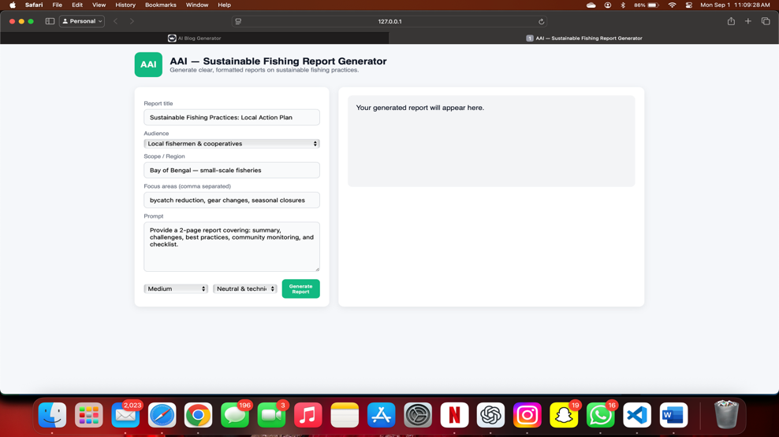

# Conclusion :-

# The *GenAI Project* successfully met its objectives. It automated the task of generating structured reports, demonstrated the effectiveness of **Flask–AI integration**, and highlighted the importance of **prompt engineering** for clean outputs.

# **Learnings:**

# API integration with Flask.

# Prompt design to control AI outputs.

# Web interface development.

# Understanding the role of AI in education.

# **Future Improvements:**

# Add export to **PDF/DOCX**.

# Support multimodal input (images, datasets).

# Provide plagiarism detection.

# Cloud hosting for multi-user access.

# This project is both a technical achievement and a socially relevant tool. It demonstrates how AI can enhance student productivity while contributing to sustainable awareness.

# References :-

1. **Perplexity AI Documentation** – Helped integrate the Sonar Pro model for report generation.
2. **Flask Documentation** – Guided backend design, request handling, and API communication.
3. **MDN Web Docs (HTML/CSS)** – Provided references for frontend design and responsive layout.
4. **Research Articles on Generative AI in Education** – Gave insights into the broader applications of GenAI.